AP Biology Name: __________________________
Evolution I Date: ________________ Per: _______
Analyzing Phylogenetic Trees
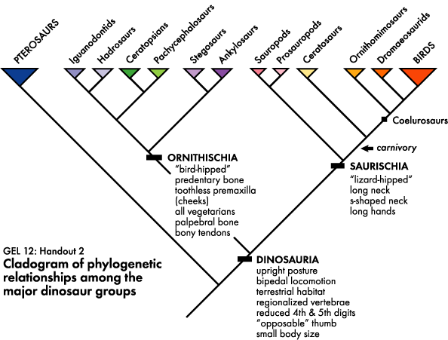
- True or False: Pterosaurs are dinosaurs. ________
- True or False: Birds are dinosaurs. _______
- Who is the most closely related group to Hadrosaurs? ________________
- What are some traits that birds and dromaeosaurids (e.g. velociraptors) share? ____________________
____________________
____________________
____________________
- Would the tree change if the the position of Stegosaurs and Ankylosaurs were switched? Why or why not?

- Would the tree change if the positions of Stegosaurs and Pachycephalosaurs were switched? Why or why not?

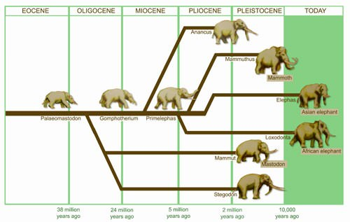
- To which group are the modern elephants more closely related (share a more recent common ancestor): the mastodon or the mammoth?
_________________________

- Estimate when the most recent common ancestor of the two modern elephants lived (or, estimate when the two modern elephants diverged).
____________________

- According to this tree, to whom is the Asian elephant more closely related: the African elephant or mammoth?
_______________________

- Propose an explanation for why groups like Anancus, the mammoth, and the mastodon might have gone extinct.

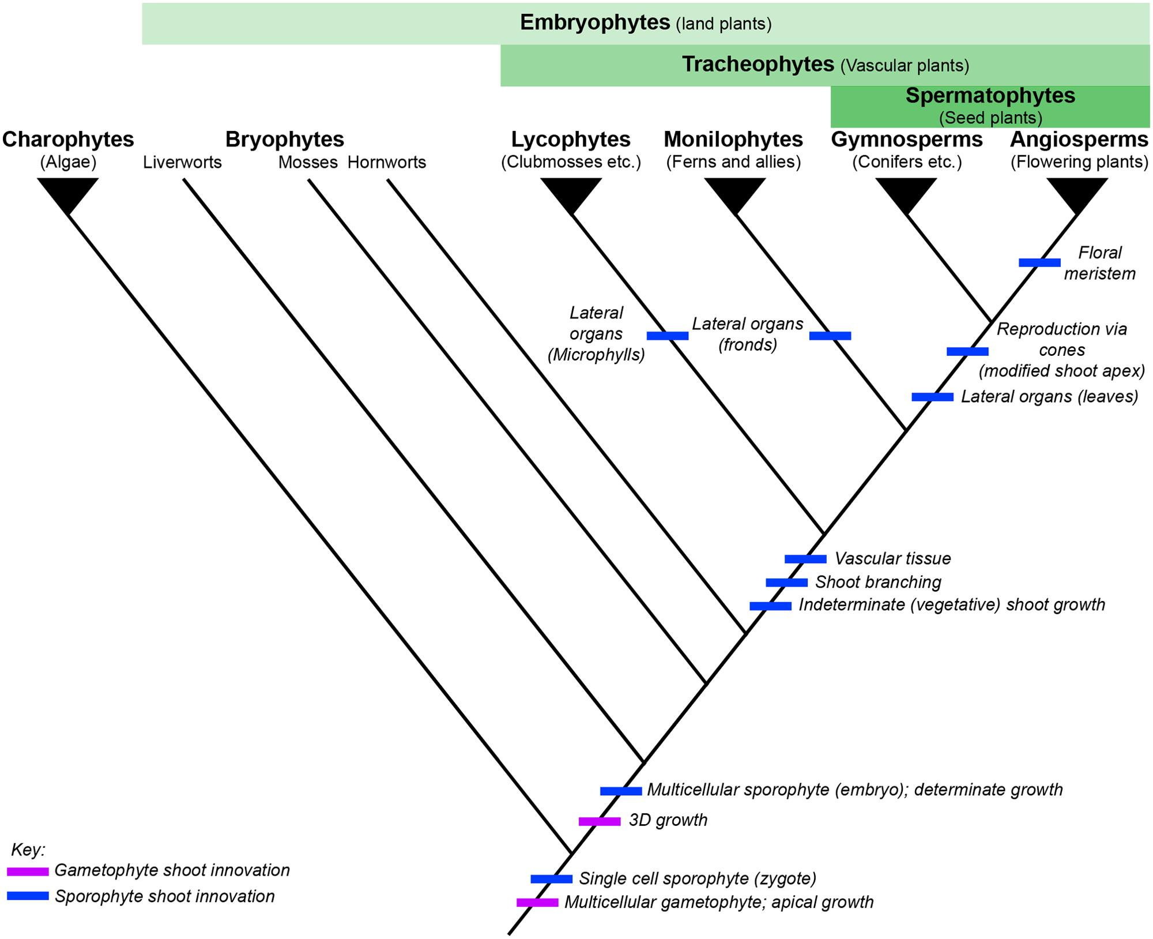
Reading this tree of plants, pick the groups that have the following traits:
- Shoot branching: _________________
_________________
_________________
_________________

- Fronds as lateral organs:
_________________

- Leaves as lateral organs:
_________________
_________________

- Reproduce via seeds:
_________________
_________________

- Flowers: _________________

Trilobite Species
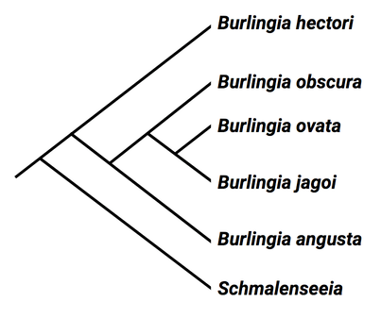
For trilobites…
- Which two species are most closely related?
_____________________________________________________

- Which name on the tree would likely be considered the outgroup? Why? _____________________________________________________
_____________________________________________________

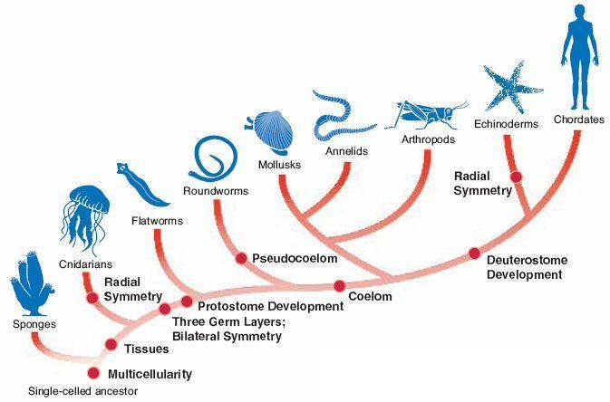
For animals…
- Name the ancestral trait. _____________________
- Which pair is more closely related?:
  - Roundworms and earthworms (annelids)
  - Mollusks and earthworms (annelids)
- According to this tree, have legs evolved multiple times? _________ When? ____________________
__________________________________________
- Explain why echinoderms and chordates are more closely related than echinoderms and mollusks.
_______________________________________
_______________________________________
Created by Ms. Maerna Kauffman

