Principles of Design Reference The recipes in a work of art or design

Principle | Visual Example That Highlights This Principle | Definition and Types
1 Balance | 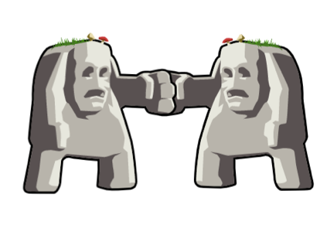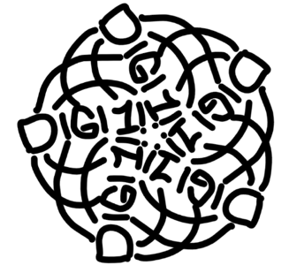 | The arrangement of objects and space in a design. (Symmetrical, approximately symmetrical, asymmetrical, radial, and uneven are typical forms)
2 Rhythm | 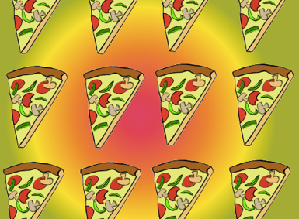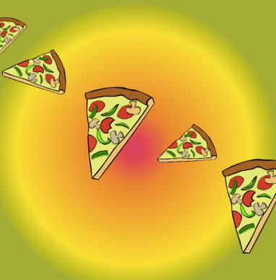 | An arrangement with repetition (if it’s consistent then it’s a pattern) that may change within the space of the design.
3 Unity |  | Although slightly different, all the visual elements and pieces share qualities and feel as if they are part of a cohesive whole.
4 Emphasis |  | The use of contrasting elements to make a particular element stand out.
5 Proportion/Scale | 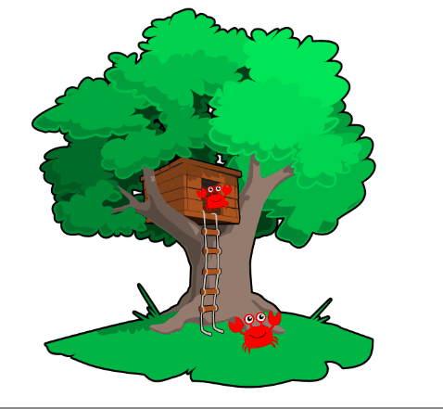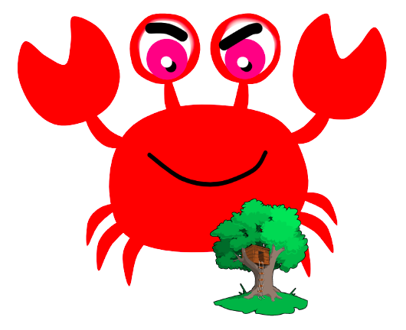  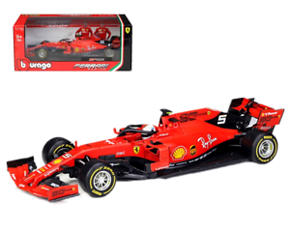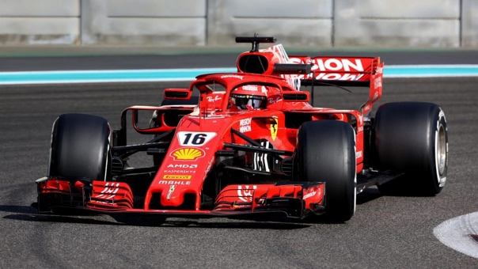  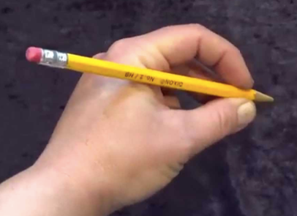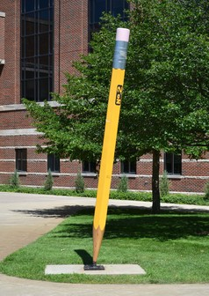 | The size of the elements within a design and the size of a design in relation to the world around it.

