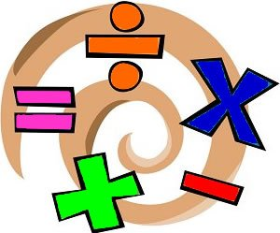
Skills Math 2020-2021 Syllabus
Mr. Kadehjian
Purple Block

Welcome to Skills Math! I am really excited to be working with you all and watching you all grow as Math students. We are going to do a lot of fun activities that will include relating different skills to the real world. The Skills math class is a year long class. This class is designed to teach and enhance your functional math skills.

Areas covered are:
- money management/budgeting,
- time
- measurement
- basic math computation
- personal consumer skills
- fractions
Goals:
- Strengthen functional to basic fundamental math concepts needed in the real world
- Organize and support mathematical thinking through communication
- Think critically and problem solve
- Ready for life

I am really looking forward to working with all of you this school year. Remember, Math is the only subject that counts!

