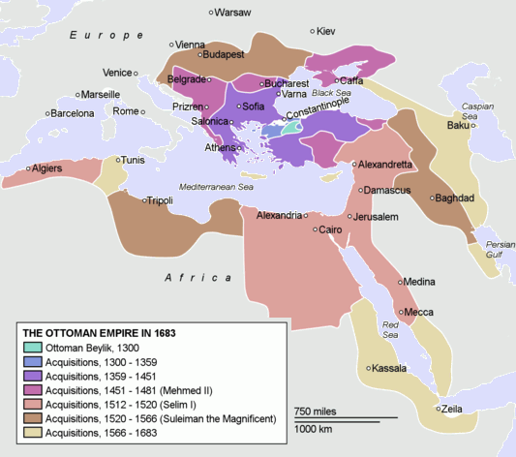

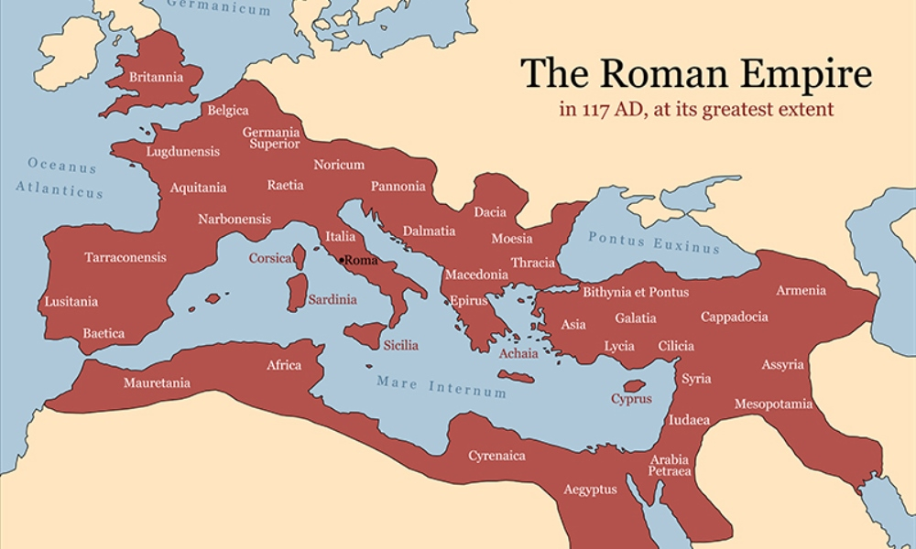
“Suleiman led his army on thirteen major military campaigns. His forces completed the conquest of the Balkans, defeated the Hungarians, captured most of the African coast, and added new possessions in the Middle East.” –Spielvogel, 521

“A brilliant general, Suleiman modernized the army and conquered many new lands.” –Ellis and Esler, 330

“Eager to provide justice for his subjects, he reorganized the government, regulated the laws of the empire, and saw that they were properly enforced.” –Spielvogel, 521

“Central government was achieved through pashas who collected taxes (and then paid a fixed percentage as tribute to the central government, maintained law and order, and were directly responsible to Istanbul.” -Duiker and Spielvogel, 423
“The Turks ruled from coastal cities like Algiers, Tunis and Tripoli and made no attempt to control the interior beyond maintaining the trade routes through the Sahara to the trading centers along the Niger River. -Duiker and Spielvogel, 423

“Europeans called him the “Grand Turk” and the “Magnificent.” –Spielvogel, 521
“At the apex of the Ottoman system was the sultan, who was the supreme authority in both the political and a military sense.” -Duiker and Spielvogel, 425

“The status and prestige of the sultan now increased relative to subordinate tribal leaders…” -Duiker and Spielvogel, 423

“Court rituals were inherited from Byzantines and Persians, and a centralized administrative system was adopted that increasingly isolated the sultan in his palace.” -Duiker and Spielvogel, 423

“When a son became sultan, his mother became known as the queen mother and served as the adviser to the throne. This tradition, initiated by the influential wife of Suleiman the Magnificent, often resulted in considerable authority for the queen mother in the affairs of the state.” -Duiker and Spielvogel, 426

“Devshirme (collection) had originated as a practice of requiring local clan leaders to provide prisoners to the sultan as part of their tax obligation.” -Duiker and Spielvogel, 426

“Senior officials were assigned land in fief by the sultan and were then responsible for collecting taxes and supplying armies to the empire.” -Duiker and Spielvogel, 427

“Sultan ruled through an imperial council that met four days a week and was chaired by the chief minister known as the grand vezir. The sultan often attended behind the screen, whence he could privately indicate his desires to the grand vezir.” -Duiker and Spielvogel, 426

“Almost all of the grand vezirs came from the devshirme system.” -Duiker and Spielvogel, 427

“Local administration during the imperial period was similar in some respects to the fief holding Europe. The empires was divided into provinces and districts governed by officials who, combined both civil and military functions. They were assisted by bureaucrats trained in the palace school in Istanbul.” -Duiker and Spielvogel, 427

“Islamic law and customs were applied to all Muslims…In practice, the sultan assigned these duties to a supreme religious authority, who administrated the law and maintained a system of schools of educating Muslims.” -Duiker and Spielvogel, 427

“Each religious group (non-Muslims) was organized into an administrative unit called a millet (nation or community). Each group had its own patriarch or grand rabbi who dealt as an intermediary with the government and administered the community according to its own laws. The leaders of individual nations were responsible to the sultan and his officials for the behavior of the subjects under their care and collected taxes for the transmission to the government.” -Duiker and Spielvogel, 427

“Outside the ruling elite, merchants were the most privileged class. They were largely exempt from government regulations and taxes and were therefore in many cases able to amass large fortunes. Charging interest was technically illegal but the rules were often ignored. In absence of regulations, merchants often charged high prices, which caused them to be bitterly resented by the other subjects of the empire.” -Duiker and Spielvogel, 428

“The Ottoman empire by the beginning of the 17th century was treated like any other European power by Europeans rulers seeking alliances or trade concessions.” -Duiker and Spielvogel, 425

“The Ottomans military discipline, ability to coordinate cavalry and infantry, and capability in logistics were usually superior to those of the Europeans.” --McKay, 651

“Mehmed the II, began the law reform. By recruiting young boys, rather than noblemen, for training as bureaucrats or military men and making them accountable directly to the sultan, he fashioned a professional bureaucracy with unswerving loyalty to the ruled. Mehmed’s successor, Suleiman the Magnificent, continued this work by compiling a comprehensive legal code. The code addressed subjects rights and duties, proper clothing, and how Muslims were to relate to non-Muslims. The code also reconciled the many differences between administrative and religious law.” –Tignor, 521
“Another set of schools, tekkes, taught devotional strategies and religious knowledge for students to enter Sufi orders. The tekkes promoted social and religious solidarity and helped integrate Muslim peoples living under Ottoman rule.” –Tignor, 521

Graduates from the madrasas learned law, religious studies and science and became ulamas, who would then served as judges or as teachers. –Tignor, 521

“Suleiman also allied with the German Protestant princes forced the Catholic leaders to grant concessions to the Protestants.” --McKay, 651

“All authority flowed from the sultan to his public servants; provincial governors, police officers, military generals, head of treasuries…” --McKay, 652

“Since all property belonged to the sultan and reverted to him on the holder’s death, Turkish nobles could not put down roots. The ruling class had the legal right to use and enjoy the profit, but not the ownership, of the land” --McKay, 652

“Suleiman ordered Lutfi Pasa, a poet of slave origin and a judicial scholar, to draw up a new general code of laws…this legal code prescribed penalties for routine criminal acts such as robbery, adultery, and murder. It also sought to reform bureaucratic and financial corruption.” --McKay, 655

“With annual states revenues of about $80 million (at a time when Elizabeth I of England could expected $150,000 an Francis I of France perhaps $1 million), with thousands of servants to cater to his whims, and with a lifestyle no European monarch could begin to rival, Suleiman was indeed magnificent.” --McKay, 655

“The cultural explosion of Suleiman’s reign rivaled the artistic and literacy achievements of the European Renaissance.” --McKay, 655

“A brilliant general, Suleiman modernized the army and conquered many new lands.” –Ellis and Esler, 330

“Although they failed to take Vienna, the Ottomans ruled the largest most powerful empire in both the Europe and the Middle East for centuries.” –Ellis and Esler, 330

“Suleiman felt justified in claiming to the be the rightful heir of the Abbasids and the caliph of all Muslims.” –Ellis and Esler, 330

“The Jewish millets brought international banking connections with them, plus a new technology for making cloth that helped the Ottoman Empire finance its expansion.” –Ellis and Esler, 330

