Collisions: 1500-1800
Key:
Spread of Christianity: Hegemonic? The Middle Passage
Private versus Public Exploration Base for Europeans in the New World
Resistance and Acceptance of change Conflicts between Europeonst and others

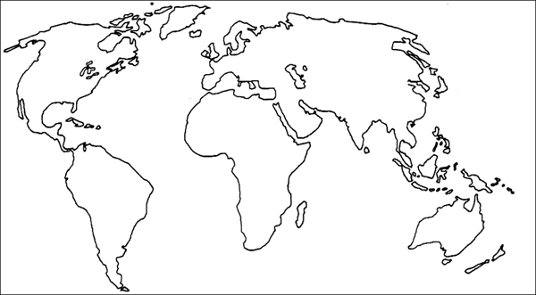

For the test, you need to be able to label all the regions, trade routes, cultural diffusions, exploration routes, and the major empires and regions we have studied.

