Directions: Read through the primary sources (with a few secondary sources) at each station. Some stations require more reading and some are analyzing images. Focus questions can be answered across the stations although some questions are clearly tailored to one station. You do NOT have to proceed through them in order but it might make sense to do one of the more reading heavy stations in between the more visual stations.

Station A: Japanese Internment Documents
Station B: Mobilization posters
Station C Women in the War
Station D American Indian Code Talkers
Station E Latinos in WWII and the Bracero Program

Focus Questions:
- How does the US mobilize its population for war?

- How do different minority and marginalized groups become involved in WWII, to what extent is their involvement, and what is their experience? How do their experiences compare and contrast? (Native Americans, women, Latinos, Labor unions, Japanese-Americans, African-Americans)

Theme of experiences and/or involvement | Japanese Americans | American Indians | Mexicans and Mexican Americans and Latinos | Women

- How does the Supreme Court and the American public justify its treatments toward people?

- How and why are the Japanese interned? What is their experience? What is the government’s role in internment? What surprises you about internment after looking at the images?

- How do oral histories/quotations enhance your understanding of WWII?

- What is the government doing? Why? How does this support or not support larger war goals?

- How would you characterize the homefront during WWII? Use single adjectives here with a few details to support each point. The objective is to find a theme.

- Who contributed what to the war effort?

- What are you finding surprising at each station?

- Considering the sacrifice of many groups, what should a WWII memorial include?

- How does hierarchy continue during WWII?

- Go onto canvas and pick one more source of your choice from the options in the WWII module. How did this enhance your understanding of WWII?

Critical Thinking Questions:

- How is the internment of the Japanese justified as constitutional? Do you agree?

- Does the internment of the Japanese violate civil liberties?

- Considering the historical context of WWII, how is this restriction on civil liberties more clearly explained?

- Overall, what can you claim about the environment impacting the experience of the Japanese internees?

- How should the internment of the Japanese Americans be remembered?

- Sketch a monument that would be erected for Japanese internment. (Consider place, materials, shape, site, and reason?
Excerpted from: Korematsu v US: Majority Decision

“In the light of the principles we announced in the Hirabayashi case, we are unable to conclude that it was beyond the war power of Congress and the Executive to exclude [p218] those of Japanese ancestry from the West Coast war area at the time they did. True, exclusion from the area in which one's home is located is a far greater deprivation than constant confinement to the home from 8 p.m. to 6 a.m. Nothing short of apprehension by the proper military authorities of the gravest imminent danger to the public safety can constitutionally justify either. But exclusion from a threatened area, no less than curfew, has a definite and close relationship to the prevention of espionage and sabotage. The military authorities, charged with the primary responsibility of defending our shores, concluded that curfew provided inadequate protection and ordered exclusion. They did so, as pointed out in our Hirabayashi opinion, in accordance with Congressional authority to the military to say who should, and who should not, remain in the threatened areas.

It is said that we are dealing here with the case of imprisonment of a citizen in a concentration camp solely because of his ancestry, without evidence or inquiry concerning his loyalty and good disposition towards the United States. Our task would be simple, our duty clear, were this a case involving the imprisonment of a loyal citizen in a concentration camp because of racial prejudice. Regardless of the true nature of the assembly and relocation centers -- and we deem it unjustifiable to call them concentration camps, with all the ugly connotations that term implies -- we are dealing specifically with nothing but an exclusion order. To cast this case into outlines of racial prejudice, without reference to the real military dangers which were presented, merely confuses the issue. Korematsu was not excluded from the Military Area because of hostility to him or his race. He was excluded because we are at war with the Japanese Empire, because the properly constituted military authorities feared an invasion of our West Coast and felt constrained to take proper security measures, because they decided that the military urgency of the situation demanded that all citizens of Japanese ancestry be segregated from the West Coast temporarily, and, finally, because Congress, reposing its confidence in this time of war in our military leaders -- as inevitably it must -- determined that they should have the power to do just this. There was evidence of disloyalty on the part of some, the military authorities considered that the need for [p224] action was great, and time was short. We cannot -- by availing ourselves of the calm perspective of hindsight -- now say that, at that time, these actions were unjustified.”
The Experience of Internment through an Environmental Lens.

“Most of the camps were in areas with frequent winds. In building the camps, the land had been recently bulldozed and the original ground cover was destroyed. The conditions were thus perfect for blowing sand and dust. ‘You couldn’t open your mouth,’ Amy Uno Ishii remembered of the Heart Mountain dust storms, ‘because all the dust would come in. You could just barely see, and the only way to keep your eyes clean was to cry and…let the tears wash your eyes.’ At Manzanar, California, on the eastern side of the Sierra Nevada, Yoriyuki Kikuchi remembered, ‘when the wind blew, it was terrible…Everybody resented being put in such a place, especially, when they were suffocated by sand.’ George Fukasawa arrived at Manzanar in the middle of one of the ‘very common’ windstorms. The residents he saw, ‘had goggles on to protect their eyes from the dust, so they looked like a bunch of monsters from another world or something. It was a very eerie feeling to get into a place under conditions like that.’ At the Utah camp (‘Topaz: The Jewel of the Desert,’ according to the official camp newspaper), Miné Okuba and Yoshiko Uchida chose the same metaphor to describe the meeting of the people with dust; ‘everyone looked like pieces of flour-dusted pastry’; ‘we looked as if we had fallen in a flour barrel.’ Monica Sone summed up the experience of arrival for many people; ‘We felt as if we were standing in a gigantic sand-mixing machine as the sixty mile gale lifted the loose earth up into the sky, obliterating everything.’ When the Stone family was assigned its room, it offered little refuge: ‘The window panes rattled madly, and the dust pored in through the cracks like smoke.’”

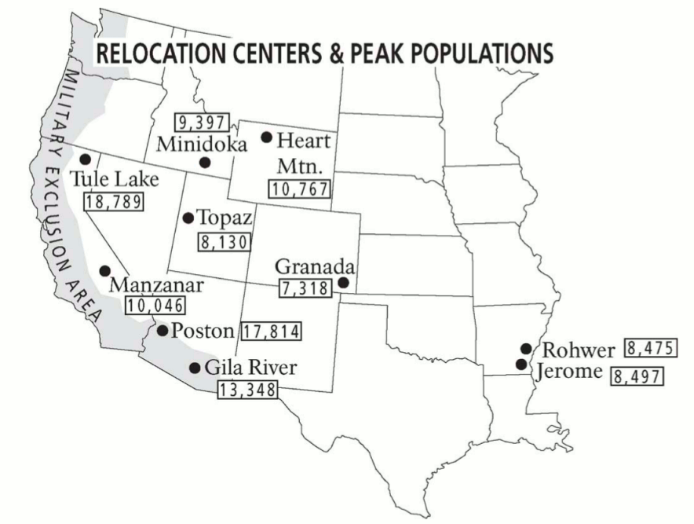
Station D Marginalized and Minority groups during the war
In America’s History: Pg 353, 354, 355
Pg 293 (Start with the paragraph “Here is the difference” to the end)
Read the handouts
Station E (The Supreme Court and Interment)
Read In America’s History:
  - Pg 298 (Start with paragraph “It is said that we” to “actions were unjustified)
  - Pg 299 (Start with paragraph “No adequate reason” to the end)
Read the dissenting opinions by Justice Jackson and Justice Roberts
Station F (Japanese views on WWII)
Read through the analysis and view from the Japanese political cartoons

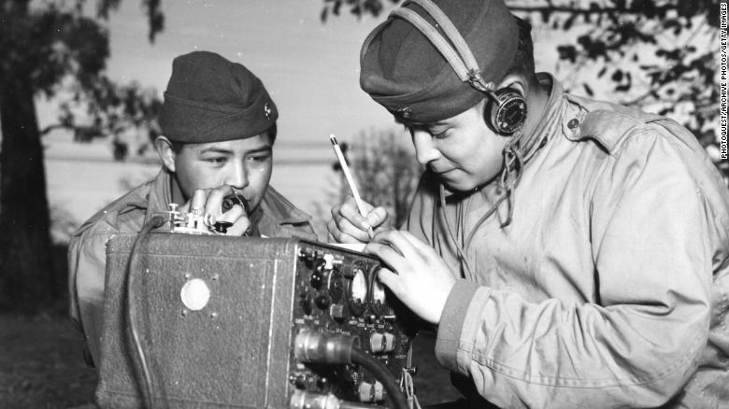
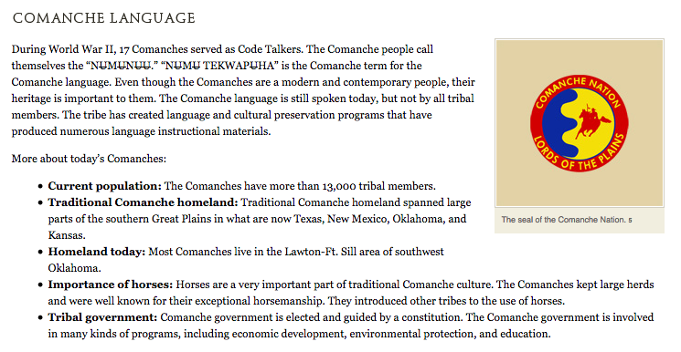

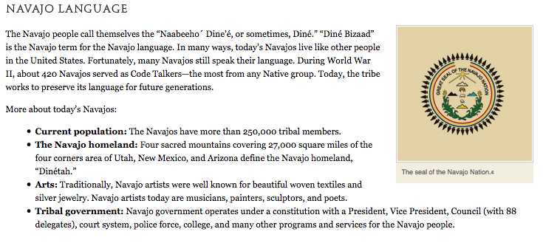
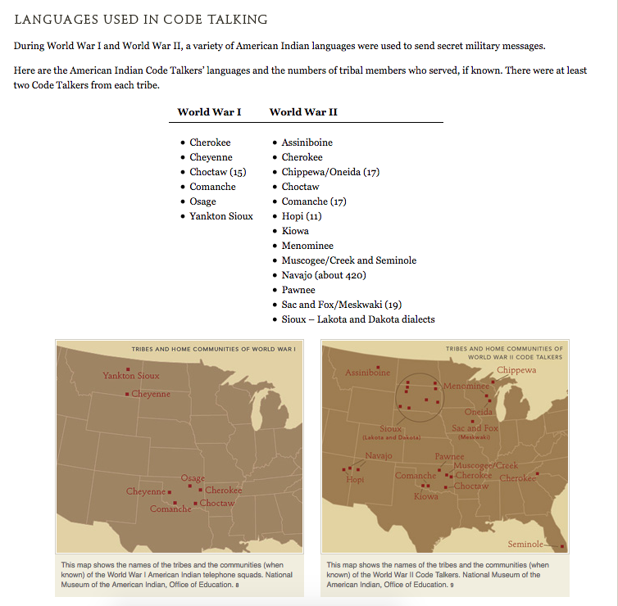
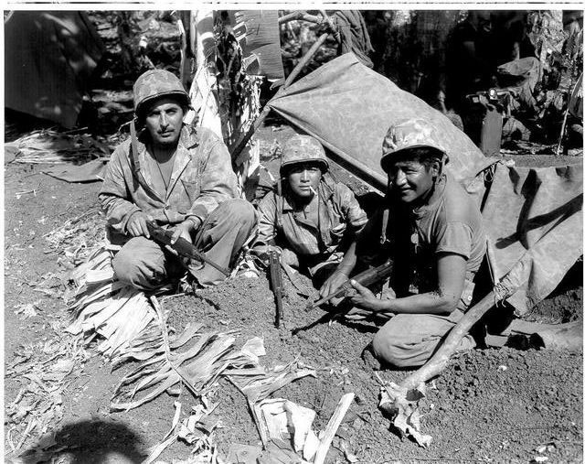
All I thought when I went in the Marine Corps was going to give me a belt of ammunition, and a rifle, a steel helmet, and a uniform. Go and shoot some of those Japanese. That’s what I thought; but later on they told us differently, you know different style, purpose of why they got us in.—Chester Nez, Navajo Code Talker, National Museum of the American Indian interview, 2004

That was about 1940, and when I got home I said, I found out they was recruiting 20 Comanches who could talk their tribe fluently for a special unit, and I told dad, “I’d like to go.”—Charles Chibitty, Comanche Code Talker, National Museum of the American Indian interview, 2004

We were drafted. They made us go. I didn’t volunteer. —Franklin Shupla, Hopi Code Talker, National Museum of the American Indian interview, 2004

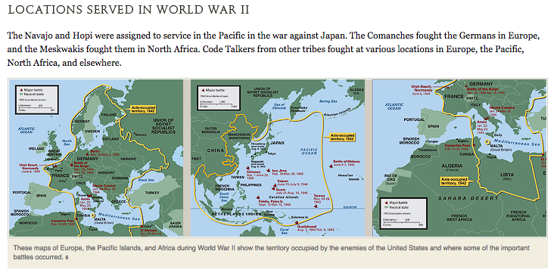
To develop their Type One Code, the original 29 Navajo Code Talkers first came up with a Navajo word for each letter of the English alphabet. Since they had to memorize all the words, they used things that were familiar to them, such as kinds of animals.
So we start talking about different things, animals, sea creatures, birds, eagles, hawks, and all those domestic animals. Why don’t we use those names of different animals—from A to Z. So A, we took a red ant that we live with all the time. B we took a bear, Yogi the Bear, C a Cat, D a Dog, E an Elk, F, Fox, G, a goat and so on down the line.—Chester Nez, Navajo Code Talker, National Museum of the American Indian interview, 2004

Here are some of the words they used:
Letter | Navajo word | English word
C | MOASI | Cat
D | LHA-CHA-EH | Dog
E | DZEH | Elk
I | TKIN | Ice
O | NE-AHS-JAH | Owl
R | GAH | Rabbit
V | A-KEH-DI-GLINI | Victor

See if you can translate the following coded message:

MOASI NE-AHS-JAH LHA-CHA-EH DZEH GAH DZEH MOASI DZEH TKIN A-KEH-DI-
GLINI DZEH LHA-CHA-EH

Letter | Navajo word | English word
C | MOASI | Cat
D | LHA-CHA-EH | Dog
E | DZEH | Elk
I | TKIN | Ice
O | NE-AHS-JAH | Owl
R | GAH | Rabbit
V | A-KEH-DI-GLINI | Victor

The Navajos, Comanches, Hopis, and others also had to develop special words for World War II military terms, such as types of planes, ships, or weapons. They were given picture charts that showed them the items. After looking at the pictures, they came up with words that seemed to fit the pictures.
“Well, when they first got us in there for Code Talkers, we had to work that out among our own selves so, we didn’t have a word for tank. And the one said it’s like a [Comanche words] he said, it’s just like a turtle, you know. It has a hard shell and it moves and so we called it a wakaree´e, a turtle.” —Charles Chibitty, Comanche Code Talker, National Museum of the American Indian interview, 2004

Native word | Literal meaning | Code Meaning
tushka chipota (Choctaw) | warrior soldier | soldier
atsá (Navajo) | eagle | transport plane
paaki (Hopi) | houses on water | ships
wakaree´e (Comanche) | turtle | tank

The, uh Mount Suribachi was on our left side just looming up. Here we started going over aboard the ship going down the net into a landing craft ship, a smaller ship. We took all our gear then we went down there. And we circulate round and round for awhile until they say go. When they say go, all those little bitty landing ships they go together right down to the beach. Before we hit the beach, the uh, officer on that ship he tell us to pray in your own belief. Me I just took out my corn powder as I was told by our medicine man and then pray. So, I think some of the kids join me to pray. —Sam Tso, Navajo Code Talker, National Museum of the American Indian interview, 2004

Utah Beach in Normandy was something else. Everybody asked me if I would go through it again, and I said, no, but I could train the younger ones how we used our language and let them go ahead and do it because it was hell.—Charles Chibitty, Comanche Code Talker, National Museum of the American Indian interview, 2004

A cup of hot water in the morning for coffee. A little bowl of soup at noon, then two potatoes at night. That’s what you live on. That’s what I lived on for three years.—Frank Sanache, Meskwaki Code Talker (discussing the meals provided for him as a prisoner of war), National Museum of the American Indian interview, 2004

We prayed to the sun, stars, whatever. It’s our way of keeping in contact with somebody. Our superior or whatever you might call him. That’s how we do it.—Franklin Shupla, Hopi, National Museum of the American Indian interview, 2004
Carl Gorman joined the United States Marine Corps in 1942 when he learned they were recruiting Navajos. He went through all of the difficult training and was one of the original 29 Navajos who were given the secret mission of developing the Navajo code. Carl answered one of his officers who had asked why Navajos were able to memorize the complex code so quickly: “For us, everything is memory, it’s part of our heritage. We have no written language. Our songs, our prayers, our stories, they’re all handed down from grandfather to father to children—and we listen, we hear, we learn to remember everything. It’s part of our training.” (Power of a Navajo: Carl Gorman, the Man and His Life, by Henry and Georgia Greenberg,1996)
Carl served in four important Pacific battles: Guadalcanal, Tarawa, Tinian, and Saipan. In 1942, Carl was stricken by Malaria, a severe tropical disease, yet he continued to fight. In 1944, Carl was evacuated from Saipan suffering both from the effects of Malaria and shell shock. Shell shock is the psychological effects of being in extremely stressful and dangerous situations, such as combat. Malaria is an infectious disease caused by a parasite spread through the bite of a mosquito. Malaria was a common disease in the Pacific islands where much of the war against Japan was fought. He had to be hospitalized and took many months to recover.
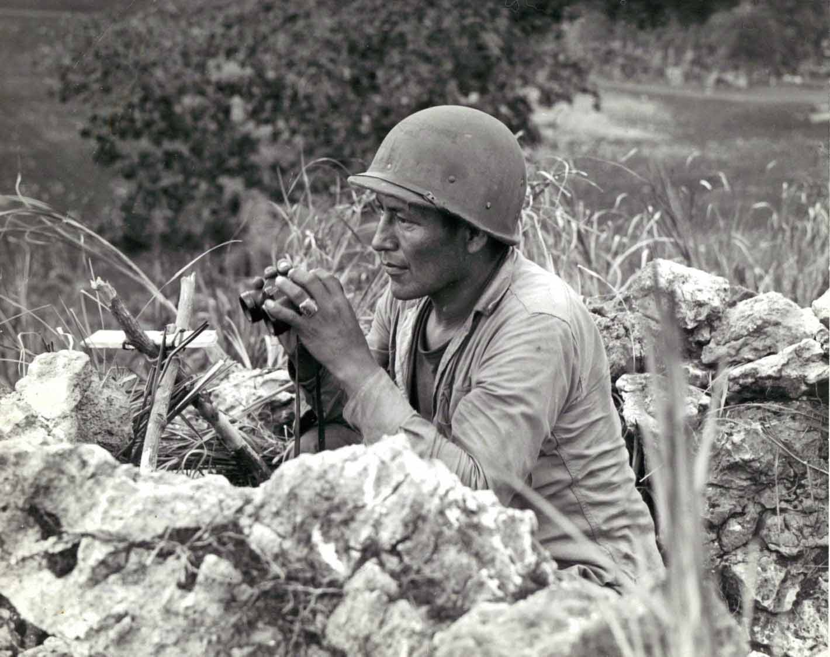

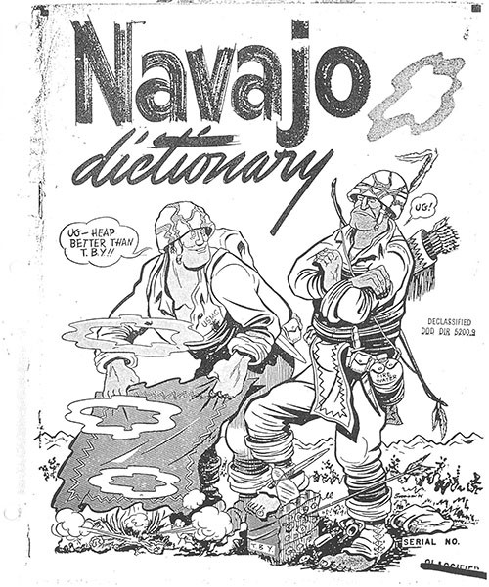
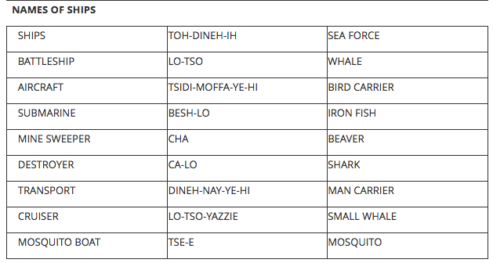

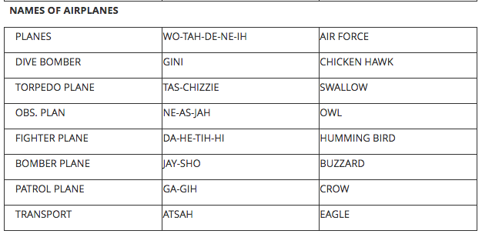

The Navajo people have different kinds of ceremonies for returning soldiers. When a soldier returns from war, his family can decide to sponsor a ceremony for him. They contact a spiritual leader, sometimes called a medicine man, who talks to the soldier about what he has experienced and decides which ceremony will be best for him. The Enemy Way ceremony, sometimes called the Squaw Dance, is one Navajo ceremony used for soldiers who were in combat, captured, or wounded.
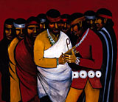
“The Black Pot Drum of the Enemy Way,” a painting by Carl Gorman, depicts a scene in the Navajo Enemy Way Ceremony. 3
Intense preparations are made and, at the appropriate time, the ceremony is conducted. Often it includes family members and others who participate in the prayers, songs, and other parts of the ceremony. These ceremonies help the Navajo war veterans return to a state of balance, or beauty, within the universe. This state of balance is called “Hozho” in the Navajo language.
Happily may their roads back home be on the trail of pollen.
Happily may they all get back.
In beauty I walk.
With beauty before me, I walk.
With beauty behind me, I walk.
With beauty below me, I walk.
With beauty above me, I walk.
With beauty all around me, I walk.
It is finished in beauty,
It is finished in beauty,
It is finished in beauty,
It is finished in beauty.
'Sa'ah naaghéi, Bik'eh hózhó
—from a Navajo Ceremony (Four Masterworks of American Indian Literature, ed. by John Bierhorst, 1974)
I had nightmares thinking about the blood. The Japanese and the smell of the dead. Rotting Japanese and they probably got into my mind. And they had a Squaw Dance for me in Crystal. And I imagine they killed that evil spirit that was in my mind. That’s what it’s about. There’s a lot of stories there. It takes a long time to talk about it. It usually takes a medicine man to explain everything properly. But it works.—John Brown, Jr., Navajo Code Talker, National Museum of the American Indian interview, 2004

There was a peyote meeting for me at the church. I was given a piece of peyote that had been blessed to keep me from harm. I think all the others were given one too. It must have worked, for all of us came back home. Yes, I still have it.— Haddon Codynah, Comanche Code Talker (Comanche Code Talkers by William C. Meadows, 2002)

My full brother, we met in Germany and we had a couple of days together there. And when he come home then, they honored us in a big prayer meeting up there at Comanche Methodist Church.
They had a big peyote church for us (Native American Church), you know, up in the tipi... And it seemed like I got more benefit out of that than I did out of the church deal because everything was traditional, you know. And I understand them old people when they pray. Beautiful prayers that morning. It was a religion that was here before white men ever got here. —Charles Chibitty, Comanche Code Talker, National Museum of the American Indian interview, 2004
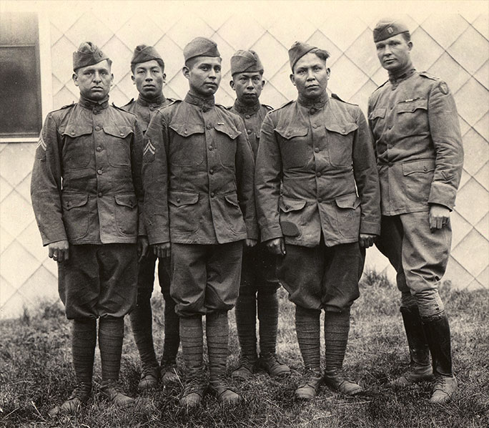
Choctaw telephone squad, returned from fighting in World War I. Camp Merritt, New Jersey, June 7, 1919. From left: Corporal Solomon B. Louis, Private Mitchell Bobb, Corporal Calvin Wilson, Corporal James Edwards, Private George Davenport, Captain E. H. Horner. Photo by Dr. Joseph K. Dixon. Courtesy Mathers Museum of World Cultures, Indiana University
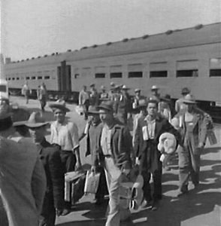
The first Braceros arriving in Los Angeles by train in 1942.
Photograph by Dorothea Lange.

In 1956, labor organizer Ernesto Galarza published a book, Strangers in Our Fields, reporting on the conditions faced by braceros in the United States. The book begins with this statement from a worker: "In this camp, we have no names. We are called only by numbers." The book concludes that workers in the program were lied to, cheated and "shamefully neglected.” In this report, federal officials attempt to refute Galarza’s findings point by point. These officials are reporting from Region X of the Bureau of Secure Employment (part of the Department of Labor), which covers Alaska, Idaho, Oregon, and Washington.

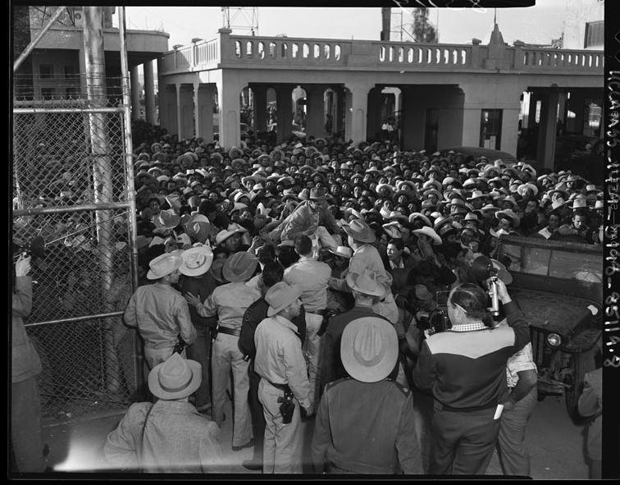

Mexican workers await legal employment in the United States, 1954

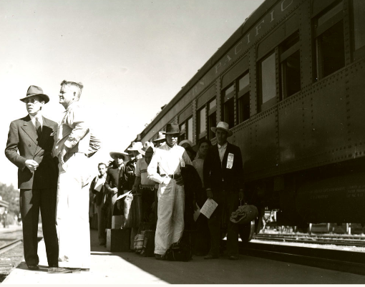

After going through the processing center in Mexico, workers were transported by train or bus to processing centers in the United States and then to bracero camps. The group pictured in this photograph is among the first group of braceros hired in 1942 to help with the sugar beet harvest near Salinas, California.
Created Date
1942-09-00
Creator
Higgins, Floyd Halleck, 1886-1975, Photographer
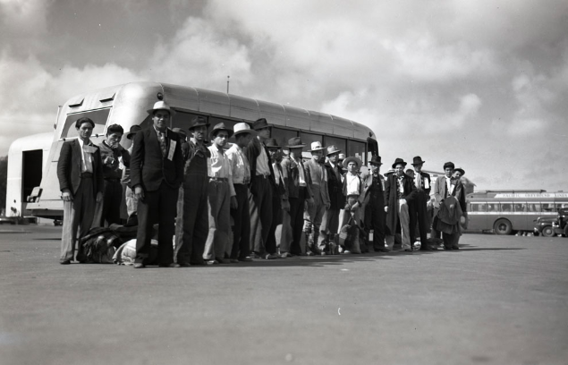

After going through the processing center in Mexico, workers were transported by train or bus to processing centers in the United States, and then to bracero camps. The group pictured in this photograph is among the first group of Braceros hired in 1942 to help with the sugar beet harvest near Salinas, California.

Created Date
1942-09-00

Description
"Mexican national laborers arrive at Salinas, California." Description by Hal Higgins.
Creator
Higgins, Floyd Halleck, 1886-1975, Photographer

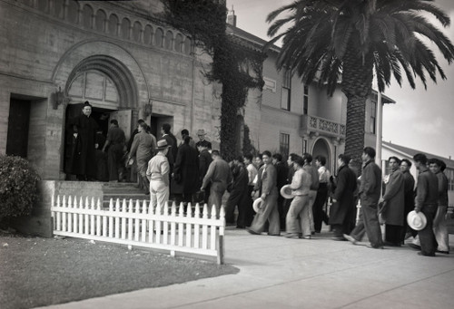

A photo of a group of braceros entering a church with the priest at the door and officials supervising, 1942.

Created Date
1942 Oct
Creator
Higgins, Floyd Halleck, 1886-1975, Photographer

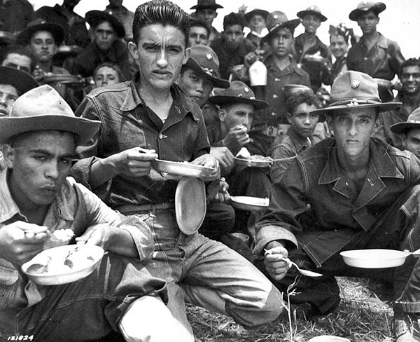
By 1940, people of Mexican descent in the U.S. were twice as likely to have been born and raised in the States than not. Often the children of immigrants who had entered in previous decades, they strongly identified with the country of their birth. The result was massive Mexican American participation in World War II, the most recent estimate being that some 500,000 Mexican Americans served in the conflict For many, a novel sensation of belonging accompanied the experience. Private Armando Flores of Corpus Christi, Texas, for example, fondly recalled being rebuked for putting his hands in his pockets on a cold day during basic training. "American soldiers stand at attention," a lieutenant told him, "They never keep their hands in their pockets." Years later, Flores still marveled at the significance of the occasion in his estimation: "Nobody had ever called me an American before!"

An excerpt from a 2011 oral history interview with a father who worked as a bracero in Arizona and his son (English translation)
LM: Dad, do you remember when you used to tell us that you used to work as a bracero and illegally? Do you remember telling us about it?
JM: When I was illegal I was in Texas. I was in ranch that was called the 90, because it was very big...
LM: And what year was that? Do you remember?
JM: No, I don't remember.
LM: It was before we were born, remember?
JM: Yes, all of you were born after I was already there.
LM: So it was around 1956 or 57 in those years when you were an illegal worker and after being an illegal worker you got a contract in a bracero program.
JM: Yes, I got a contract to come to work in California.
LM: Do you remember what that job was?
JM: They used to make a list then they would take you, not everyone, one here and there, to the center of contracts in Guadalajara and they...
LM: The commissario would make the list, he would look for the candidates, he would look for the people...
JM: Yes, but he wouldn't include everyone...
LM: No, not everyone, only certain people...
JM: Once they made the list they would take them to Guadalajara and they would do the contracts there.
LM: How would they send you there when they contracted you...in cars, in airplanes, in donkeys...in trains…?
JM: In trains.
LM: Ah, in trains. So you went from Balded Sonora to the United States…
JM: Yes and from there they would give you the passports.
LM: Who would decide where u were going to work? Who would decide that…?
JM: In Parma and Sonora, a lot of them would go to different places...and some would be sent to Arizona and I imagine they wanted to go because it was very hot over here...
LM: So the bosses would arrive, looking for manual laborers, and braceros from Mexico would arrive. So, would they say, I have some work Texas or I have work in California or I have work in Arizona...
JM: It depended, some wanted twenty, thirty, forty, or fifty people.
LM: So was it voluntary, and you could say, I want to go to California, or I want to go to Texas?
JM: Many wanted to go to Arizona because it is very hot there and that was what they were used to.
LM: What did you used to do in San Jose?
JM: Picked cucumbers and zucchini.
LM: And how did they used to pay you, by hour or by contract?
JM: Per hour.
LM: Do you remember how much they used to pay you?
JM: I used to get paid $1.25 an hour.
LM: And why did you decide to come here, because mom brought you here or what?
JM: Once the contract was over in Sonoma, then we came here.
Citation Information
Marquez, Luis and José Marquez, “Oral History with Luis Marquez and José Marquez,” Digital Public Library of America, http://dp.la/item/810aad4d4402c50919a1a31af41ea729.

The massive mobilization effort that the war required, moreover, ensured widespread participation from non-combatants. Countless Latinas joined the Army's WACS, the Navy's WAVES, or similar all-female auxiliary units associated with the U.S. Air Force. Just 19, Maria Sally Salazar of Laredo, Texas, for example, was so eager to join the Army's Women Army Corps that she borrowed her sister's birth certificate so that she could pass for 21, the minimum age requirement for women. After basic training, she spent 18 months in the Philippine jungle working out of an administrative building but also tending the wounded when needed. In addition, thousands of Mexican American men and women found jobs in defense industries, an opportunity that was almost denied them because anti-Mexican prejudice remained so high. Although President Franklin Roosevelt had issued an executive order in 1941 banning discrimination in defense industry hiring, the war's seemingly ceaseless demand for labor soon proved more effective in trouncing employer reluctance to hire Latino workers. The upshot was that wartime sacrifice was often a family affair. The Sanchez family, transplanted from Bernalillo, New Mexico to Southern California before the war, is a case in point. Of ten grown siblings, three sisters each became a "Rosita the Riveter," while all five brothers served: two as army soldiers, one as an army medic, one as a Seabee, that is, a member of U.S. Navy Construction Battalion, and the eldest, who turned 50 during the war, as a civil defense air-raid warden. The family's participation was so extensive that members remember waiting to hear of one brother's fate during the Battle of the Bulge just after hearing another brother had died in combat in the Philippines.

The Contributions of Hispanic Servicewomen
Written by: Judith Bellafaire, Ph.D., Curator
Women In Military Service For America Memorial Foundation, Inc.
history@womensmemorial.org
Carmen (Contreras) Bozak joined the Women’s Army Auxiliary Corps (WAAC) in 1942. The Army was looking for bilingual Hispanic women to fill assignments in fields such as cryptology, communications and interpretation. Bozak volunteered to be part of the 149th WAAC Post Headquarters Company—the first to go overseas—and went to North Africa in January 1943. Serving overseas was dangerous for these women. If captured, WAACs, as “auxiliaries” serving with the Army rather than in it, did not have the same protections under international law as male soldiers. Tech 4 Bozak worked as an interpreter at Army Headquarters in Algiers, and dealt with nightly German air raids.
Sergeant Mary (Valfre) Castro, the first Hispanic woman from San Antonio, TX, to join the WAAC, signed up to help bring home the seven men in her family who were fighting in the Southwest Pacific. The Army sent her to radio school in St. Louis, MO, where she learned to transcribe encoded radio messages. After Castro completed radio school, the Army assigned her to Barksdale Air Force Base (AFB), LA. Instead of working in a position for which she had been trained, she became a drill sergeant for new Women’s Army Corps (WAC) recruits.
In 1944, the Army sent three WAC recruiters to the island of Puerto Rico to organize a unit of 200 WACs. The young women of the island responded enthusiastically, and over 1,500 applications were submitted. The women selected were trained at Ft. Oglethorpe, GA, and assigned, as a single unit, to the New York City Port of Embarkation. They worked in the military offices that planned the shipment of troops around the world. When the war ended, the women helped millions of soldiers to return home before they themselves returned to Puerto Rico in 1946. Private First Class Carmen M. Medina, born in San Sebatian, was a member of this WAC detachment. Private Medina worked as a clerk typist in an Army post office at the port. She is proud of her service and believes that it was the most important thing she has ever endeavored to do.
Hispanic women also served as nurses during World War II. Army nurse Carmen Salazar of Los Angeles, CA, was assigned to a hospital train unit at the Presidio in San Francisco. The unit transported wounded servicemen from Letterman General Hospital to military hospitals across the United States. Second Lieutenant Salazar’s patients included ex-prisoners of war who had survived the Bataan Death March.
When large numbers of Puerto Rican troops were inducted into the Army in 1944, the Army Nurse Corps decided to actively recruit Puerto Rican nurses so that Army hospitals would not have to deal with language barriers. Thirteen women submitted applications and were accepted into the Army Nurse Corps. They were Venia Hilda Roig, Rose Mary Glanville, Asuncion Bonilla-Velasco, Elba Cintron, Casilda Gonzalez, Olga Gregory, Eva Garcia, Marta Munoz-Otero, Margarita Vilaro, Medarda Rosario, Aurea Cotto, Julie Gonzalez, and Carmen Lozano. Eight of the nurses were assigned to the army post at San Juan, and four worked at the hospital at Camp Tortuguero, a training center near Vega Baja.
Carmen (Lozano) Dumler, one of the thirteen, knew that she wanted to be an Army nurse when she graduated from the Presbyterian Hospital School of Nursing in the spring of 1944. She was sworn in as a second lieutenant on August 21, 1944, and remembers it as the proudest day of her life. Her first assignment was at the 161st General Hospital in San Juan. The Army then sent her to Camp Tortuguero. The patients were happy to have a Spanish-speaking nurse to whom they could relate. Lieutenant Dumler assisted as an interpreter whenever necessary. Her next assignment was at the 359th Station Hospital at Ft. Read, Trinidad, British West Indies. While there, she nursed soldiers recovering from wounds they had received at Normandy. The soldiers appreciated being able to talk out their anxieties and nightmares with someone who shared their language.
Lieutenant Maria (Garcia) Roach served as a flight nurse with the Army Nurse Corps in the China-Burma-India Theater of Operations, and received an Air Medal and two Bronze Stars for her heroic actions. First Lieutenant Jovita (Soto) Mounsey joined the Army Nurse Corps in 1945, and was assigned to the William Beaumont Army Hospital in El Paso, TX, where she worked on the surgical ward and cared for orthopedic patients. After the war, Lieutenant Mounsey was sent to Europe, and served with US forces in Belgium, France and Occupation Germany.

Beginning in World War II, the Bracero Program brought Mexican laborers to the United States to remedy wartime production shortages. The program (which derived its name from the Spanish word for a manual laborer, “bracero”) continued until 1964, with braceros working mainly in agricultural areas in the Southwest and on the West Coast. Braceros worked long hours for low wages in difficult jobs that separated them from their families. In the United States, they also faced discrimination and became the subject of national labor debates. Get new insight into the Bracero Program and its workers through this collection of era photographs, documents, and oral history interviews.

Nearly 350,000 American women served in uniform, both at home and abroad, volunteering for the newly formed Women’s Army Auxiliary Corps (WAACs, later renamed the Women’s Army Corps), the Navy Women’s Reserve (WAVES), the Marine Corps Women’s Reserve, the Coast Guard Women’s Reserve (SPARS), the Women Airforce Service Pilots (WASPS), the Army Nurses Corps, and the Navy Nurse Corps. General Eisenhower felt that he could not win the war without the aid of the women in uniform. “The contribution of the women of America, whether on the farm or in the factory or in uniform, to D-Day was a sine qua non of the invasion effort.” (Ambrose, D-Day, 489)

In early February 1942, the War Department created 12 restricted zones along the Pacific coast and established nighttime curfews for Japanese Americans within them. Individuals who broke curfew were subject to immediate arrest. The nation’s political leaders still debated the question of relocation, but the issue was soon decided. On February 19, 1942, Pres. Franklin D. Roosevelt signed Executive Order 9066, which gave the U.S. military authority to exclude any persons from designated areas. Although the word Japanese did not appear in the executive order, it was clear that only Japanese Americans were targeted, though some other immigrants, including Germans, Italians, and Aleuts, also faced detention during the war. On March 18, 1942, the federal War Relocation Authority (WRA) was established. Its mission was to “take all people of Japanese descent into custody, surround them with troops, prevent them from buying land, and return them to their former homes at the close of the war.”

Beginning in 1940, the army recruited Comanches, Choctaws, Hopis, Cherokees, and others to transmit messages. The army had special American Indian recruiters working to find Comanches in Oklahoma who would enlist.
The Marine Corps recruited Navajo Code Talkers in 1941 and 1942. Philip Johnston was a World War I veteran who had heard about the successes of the Choctaw telephone squad. Johnston, although not Indian, had grown up on the Navajo reservation. In 1942, he suggested to the Marine Corps that Navajos and other tribes could be very helpful in maintaining communications secrecy. After viewing a demonstration of messages sent in the Navajo language, the Marine Corps was so impressed that they recruited 29 Navajos in two weeks to develop a code within their language.

