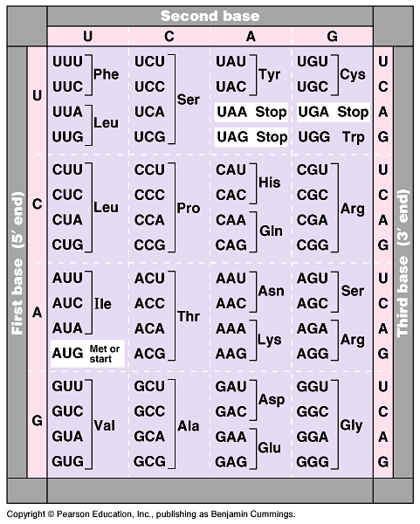

Codon Chart- ONLY to be used with mRNA!

